CALL FOR ARTISTS
The Artist Residency Program (ARP) provides a variety of opportunities for artists to work in the community, to develop a wide range of arts-based projects and activities with diverse publics and to deliver creative projects that generate meaningful connections for participants as well as for the broader community.

In 2020 the NVRC is seeking proposals from artists in one of four key areas:

- work that offers an opportunity for self-expression and exploration for communities that have historically been marginalized (e.g. LGBTQ2+ communities and/or ethnically-culturally diverse immigrant populations)

- work that explores reconciliation and building relationships between Indigenous peoples and settler populations

- work that focuses on establishing intergenerational connections

- work that connects recreation and culture

APPLICATION DEADLINE: Tuesday, April 28, 2020 at 4:30 pm

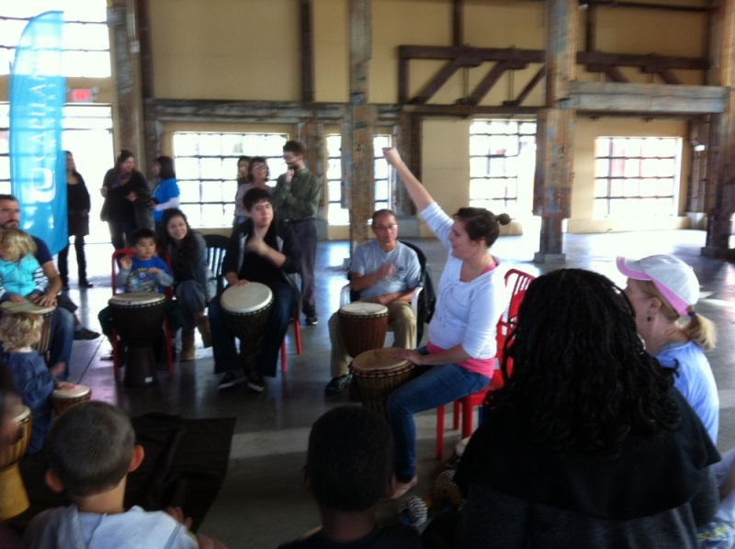
Community Drumming Circle at the Pipeshop

The ARP is seeking artists whose practice and/or proposal involves working collaboratively with community members (who may or may not see themselves as artists or as artistically creative) in initiatives where the participants take a central role as creators, producers and performers or as active audiences for the project.

Contributing to the growing vibrancy of our neighbourhoods,
the ARP seeks to inspire participation and relationship-building
where art acts as a catalyst for individual and community engagement.

Please read the Artist Residency Program Guidelines before completing the attached application: https://www.nvrc.ca/arts-culture/artist-residency-program

A P P L I C A T I O N F O R M
1. Name & Contact Information
The NVRC Artist Residency Program does not offer a live-in residency. It is open only to artists who live or work in North Vancouver, on the North Shore or in Metro Vancouver, BC, Canada.

If submitting an application on behalf of a collective or as part of a collaborative proposal, ONE LEAD ARTIST should provide their address and contact information, with the names of the other artist(s) listed below.

NAME:
ADDRESS: Please use Verdana 10pt
CITY: PROVINCE: BC
POSTAL CODE:
E-MAIL: PHONE: ( ) -

OTHER ARTISTS:

N.B. It is the applicant’s responsibility to ensure that their contact information is up-to-date and that any changes are provided to the Program Officer.
2. Artists’ Statement
Please provide a brief statement, describing your artistic practice. If the application is being submitted on behalf of a collective, please provide a brief mission statement for the group.
(200 WORDS)

3. Artist Qualifications / CV
Please submit a current CV on behalf of each of the artists listed above. CVs should:
- be a maximum of 3 pages
- describe previous residencies, provide information on other relevant projects and/or provide a recent exhibition record
- be attached to this application and submitted as a .pdf

R E S I D E N C Y P R O P O S A L
The Artist Residency Program seeks to:
- support the exploration of creativity;
The Artist Residency Program provides access to creation space, covers material costs and offers funding options to artists.

- build community by making art together; AND
Community-engaged arts practices are cooperative and participatory; they focus on shared exploration, creation and relationship-building rather than on the transmission of technical skills from teacher to student.

- ensure that participation in the arts is accessible to all.
Participation in community-cultural development projects is open to all, regardless of age, sex, ability or economic status. Programs are designed to be welcoming to and to encourage the participation of those publics that have traditionally been underserved or that are marginalized within our communities.

4. Program Categories
In order to meet the above program goals, the Artist Residency Program offers three distinct streams or categories. Please check one or more of the boxes below to indicate each of the program categories you are interested in participating in.

Creation Labs
Creation Lab Residencies offer studio time to artists to experiment with new ideas, to play with and create new directions in their practice, to develop new “work” and to present it in a workshop setting. Creation Labs are self-directed, intensive and of relatively short duration (six weeks to four months); they are expected to culminate in some kind of public activity, demonstration, open house, showcase or workshop.

Creating Connections
Creating Connections residencies offer a framework for professional artists to work directly with members of the community. The program is typically built around a dedicated, pre-determined area of focus or theme with a goal to encourage the development of a wide variety of interactions between artists and community members. Projects are highly participatory, encourage acts of shared creation and support life-long learning. The Creating Connections program is open to solo artists or small artist collectives. Residencies are concentrated in a term of two to four months.

Community Residency
Based at the John Braithwaite Community Centre (JBCC), the Community Residency is expected to last six to nine months. Space at JBCC will be made available during the Centre’s opening hours and will act as a home base and small office/studio. Artist(s) will be expected to spend their time “in residence,” establishing a presence at JBCC and in the surrounding neighbourhood, interacting with and engaging the public in a range of creative practices. The goal of the program is to invite community members and curious visitors to share in creating activities that are collaborative, cooperative and community-building.

For more detailed descriptions for each of the above program streams, please refer to the Artist Residency Program Guidelines, available on the NVRC website at:
https://www.nvrc.ca/arts-culture/artist-residency-program

5. Artistic Practice / Type of Work
Please check any boxes below that provide a general description of your artistic practice or of the type of work you are proposing for the residency program.

Visual Arts, 2-D Sculptural
Multi-media Photography/Photo Based
Digital & New Media Theatre
Music Poetry
Dance Performance Based
Literary Arts Spoken Word
Other (please describe):

6. Proposal
Please read the Artist Residency Program Guidelines and ensure that your proposal relates to the specific characteristics of the program category or categories that you are applying to as well as the creation spaces that are available.

Your proposal should include an estimate of the amount of time required to complete your proposed residency. The following information is provided as a guideline:
Creation Lab … typically six weeks to four months
Your proposed length of residency:
Creating Connections … typically two to four months
Your proposed length of residency:
Community Residency … six to nine months
Your proposed length of residency:
Describe the project or body of work you intend to explore through your participation in the Artist Residency Program. Please include details about process, practice, materials, outcomes and a timeline.

Residency terms may not have to be completed by year-end, 2020. Proposals will be considered that span the end of 2020 and may go into 2021.
(400 WORDS)

7. Public Programs
Outline the ways in which you intend to engage the public through art – i.e. the activities or programs you will facilitate as part of your residency. These may include workshops, lectures, special events, demonstrations, classes, or any other public event that will contribute to the requirement within each residency category.
(400 WORDS)

B U D G E T

The 2020 Artist Residency Program has a total budget of $25,500 to fund between four and six projects. Project fees may range from $2,500 to a maximum of $8,500 and are intended to cover artist fees, materials and project costs.

The Selection Panel will make a determination regarding how best to allocate available funds.

However, please be advised that the NVRC is not obliged to accept any of the submissions and reserves the right to reject all submissions and to reissue the Call for Artists as required.

Please provide a brief outline of your budget expectations, including Artist Fees (hourly rate and number of hours), public program costs, materials, etc.

Legal Note
All submissions become the property of the NVRC. All information provided as part of the submission is subject to the Freedom of Information and Protection of Privacy Act (BC) and shall only be withheld from release if an exemption from release is permitted by the Act. The applicant shall retain copyright of the submitted documents.

I N F O R M A T I O N, E N Q U I R I E S & S U B M I S S I O N
INFORMATION WORKSHOPS: CANCELLED
APPLICATION DEADLINE: Tuesday April 28, 2020 by 4:30pm

PROGRAM GUIDELINES: The Artist Residency Program Guidelines, including full program descriptions, evaluation criteria and submission requirements can be found at:
https://www.nvrc.ca/arts-culture/artist-residency-program

ENQUIRIES: All enquiries should be directed to:
artist-residencies@nvrc.ca

ELECTIONIC SUBMISSION: Deliver completed grant application package by email to:
artist-residencies@nvrc.ca

APPLICATION CHECK-LIST: SIGNED APPLICATION FORM
CURRENT CVs
LETTERS OF RECOMMENDATION (if available)
IMAGES OF PREVIOUS WORK
VIDEO (if available)
IMAGE LIST

S I G N A T U R E
Signature of Person filing the application  (identified as Contact Person on Page 2) | Name:
 | Date:

