Arts and Culture Grants
Client Profile

Unless otherwise stated, the submission of a Client Profile is typically a required part of applications to the following grants programs:
OPERATING ASSISTANCE
- All applicants
PROGRAMMING & PROJECT ASSISTANCE
- Program & Project Grants
- Annual Programming Support
CELEBRATIONS & EVENTS GRANTS
- Major Celebrations Grants
- Arts Festivals Grants

Established grants clients will have their Client Profile kept on file for up to a maximum of five years.

New applicants – i.e. groups who have not previously applied for an Arts & Culture grant – must ensure that they have submitted a Client Profile if one is required as part of their current application package (see above).

It is the responsibility of all applicants to ensure that they have an up-to-date Client Profile on file with Grants Program staff, or that they have submitted a current profile with their current grant request.

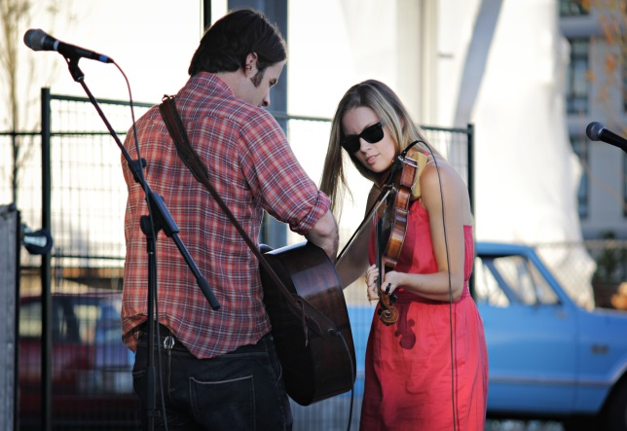
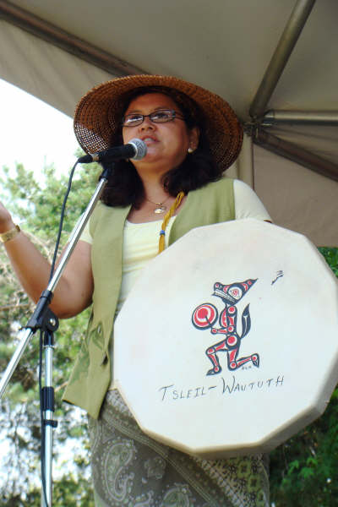
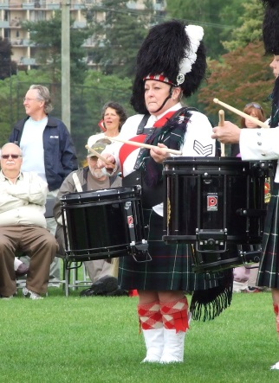
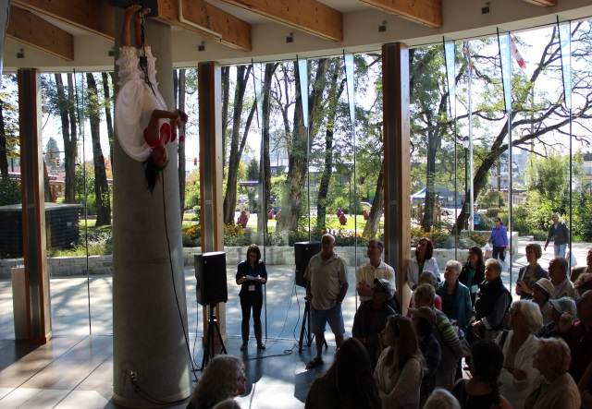

1. General Information
OFFICIAL SOCIETY NAME
…
OPERATING AS / … NAME OF ORGANIZATION IF DIFFERENT FROM ABOVE
…
MAILING ADDRESS
…

CITY PROVINCE POSTAL CODE
… BC …
ORGANIZATIONAL WEBSITE
…
2. Primary Contact (person completing application)
NAME TITLE WITH ORGANIZATION

E-MAIL PHONE (1) PHONE (2)

3. Society Status
Is your organization incorporated as a not for profit society? YES NO

… or does it have charitable status? YES NO

If you answered YES to either of the above, please provide: your BC society number

and/or YOUR charity number

4. History, Mission & Mandate
HISTORY
Provide a brief overview of the history of your organization and your activities in North Vancouver.
(100 WORDS)
…

mission & mandate
Speak to your vision, mission and mandate as a non-profit society or recognized community group.
(125 WORDS)
…

5. Governance & Management ~ not-for-profits and charitable groups
If you ARE registered as a not-for-profit society or have charitable status, or if you identified as such in Question 3, please speak to the governance structure and practices of your organization.

ROLE OF THE BOARD
Is yours a working board or a policy/governance board?
How is your board involved in the management of the organization, either in terms of day-to-day operations or general governance and oversight.
What experience and skills do individual members of your board bring to the organization?
Do NOT describe the functions of different board positions!

What challenges do you face in respect of recruitment, renewal or turnover?
(200 WORDS)
…

6. Governance & Management ~ other recognized arts or community groups
ONLY ANSWER THIS QUESTION if you did not answer Question 5, above.

GOVERNANCE & ACCOUNTABILITY
If you are NOT registered as a not-for-profit society or do NOT have charitable status, please speak to the governance structure and practices of your organization.

Does your group have a board or a management committee?

How do you ensure responsibility and accountability for the management of the group?
(100 WORDS)
…

PATH TO NOT-FOR-PROFIT STATUS
Do you have plans to incorporate as a not-for-profit society?
If you answered NO, please speak to reasons you have identified as to why incorporating as a not-for-profit society is NOT the right move for your group.
If YES, please suggest a timeline to complete these plans. What challenges or barriers do you face in respect of incorporating as a not-for-profit society?
(200 WORDS)
…

7. Profile Update
I, the undersigned, certify that, to the best of my knowledge, all information provided in this Client Profile is accurate and true and is endorsed by the organization I represent.
SIGNATURE OF PERSON FILING THE APPLICATION NAME

DATE SUBMITTED

STAFF USE – RENEWAL REQUIRED BY:

The application may be submitted with the electronic signature (if available) of the Primary Contact identified on page 2 of this form …
OR the signature page may be submitted separately as a scanned .pdf, showing the Primary Contact’s original signature.

REQUIRED ATTACHMENTS – ANNUAL UPDATES
It is the responsibility of all applicants to keep their Client Profile updated as the organization changes over time. This may include Annual Updates as itemized below.
If available please provide the following:
An annotated List of the Board of Directors (or Management Committee), including: name, board position and years of service.
UPDATE EVERY YEAR
A full membership list with names and addresses.
PROVIDE IF AVAILABLE – UPDATE EVERY YEAR
An annotated org chart, including: job titles, FTE, names (if positions filled) and reporting structures. Indicate where roles are being filled by volunteers (v).
UPDATE AS REQUIRED

